Max Kochetov Biography:

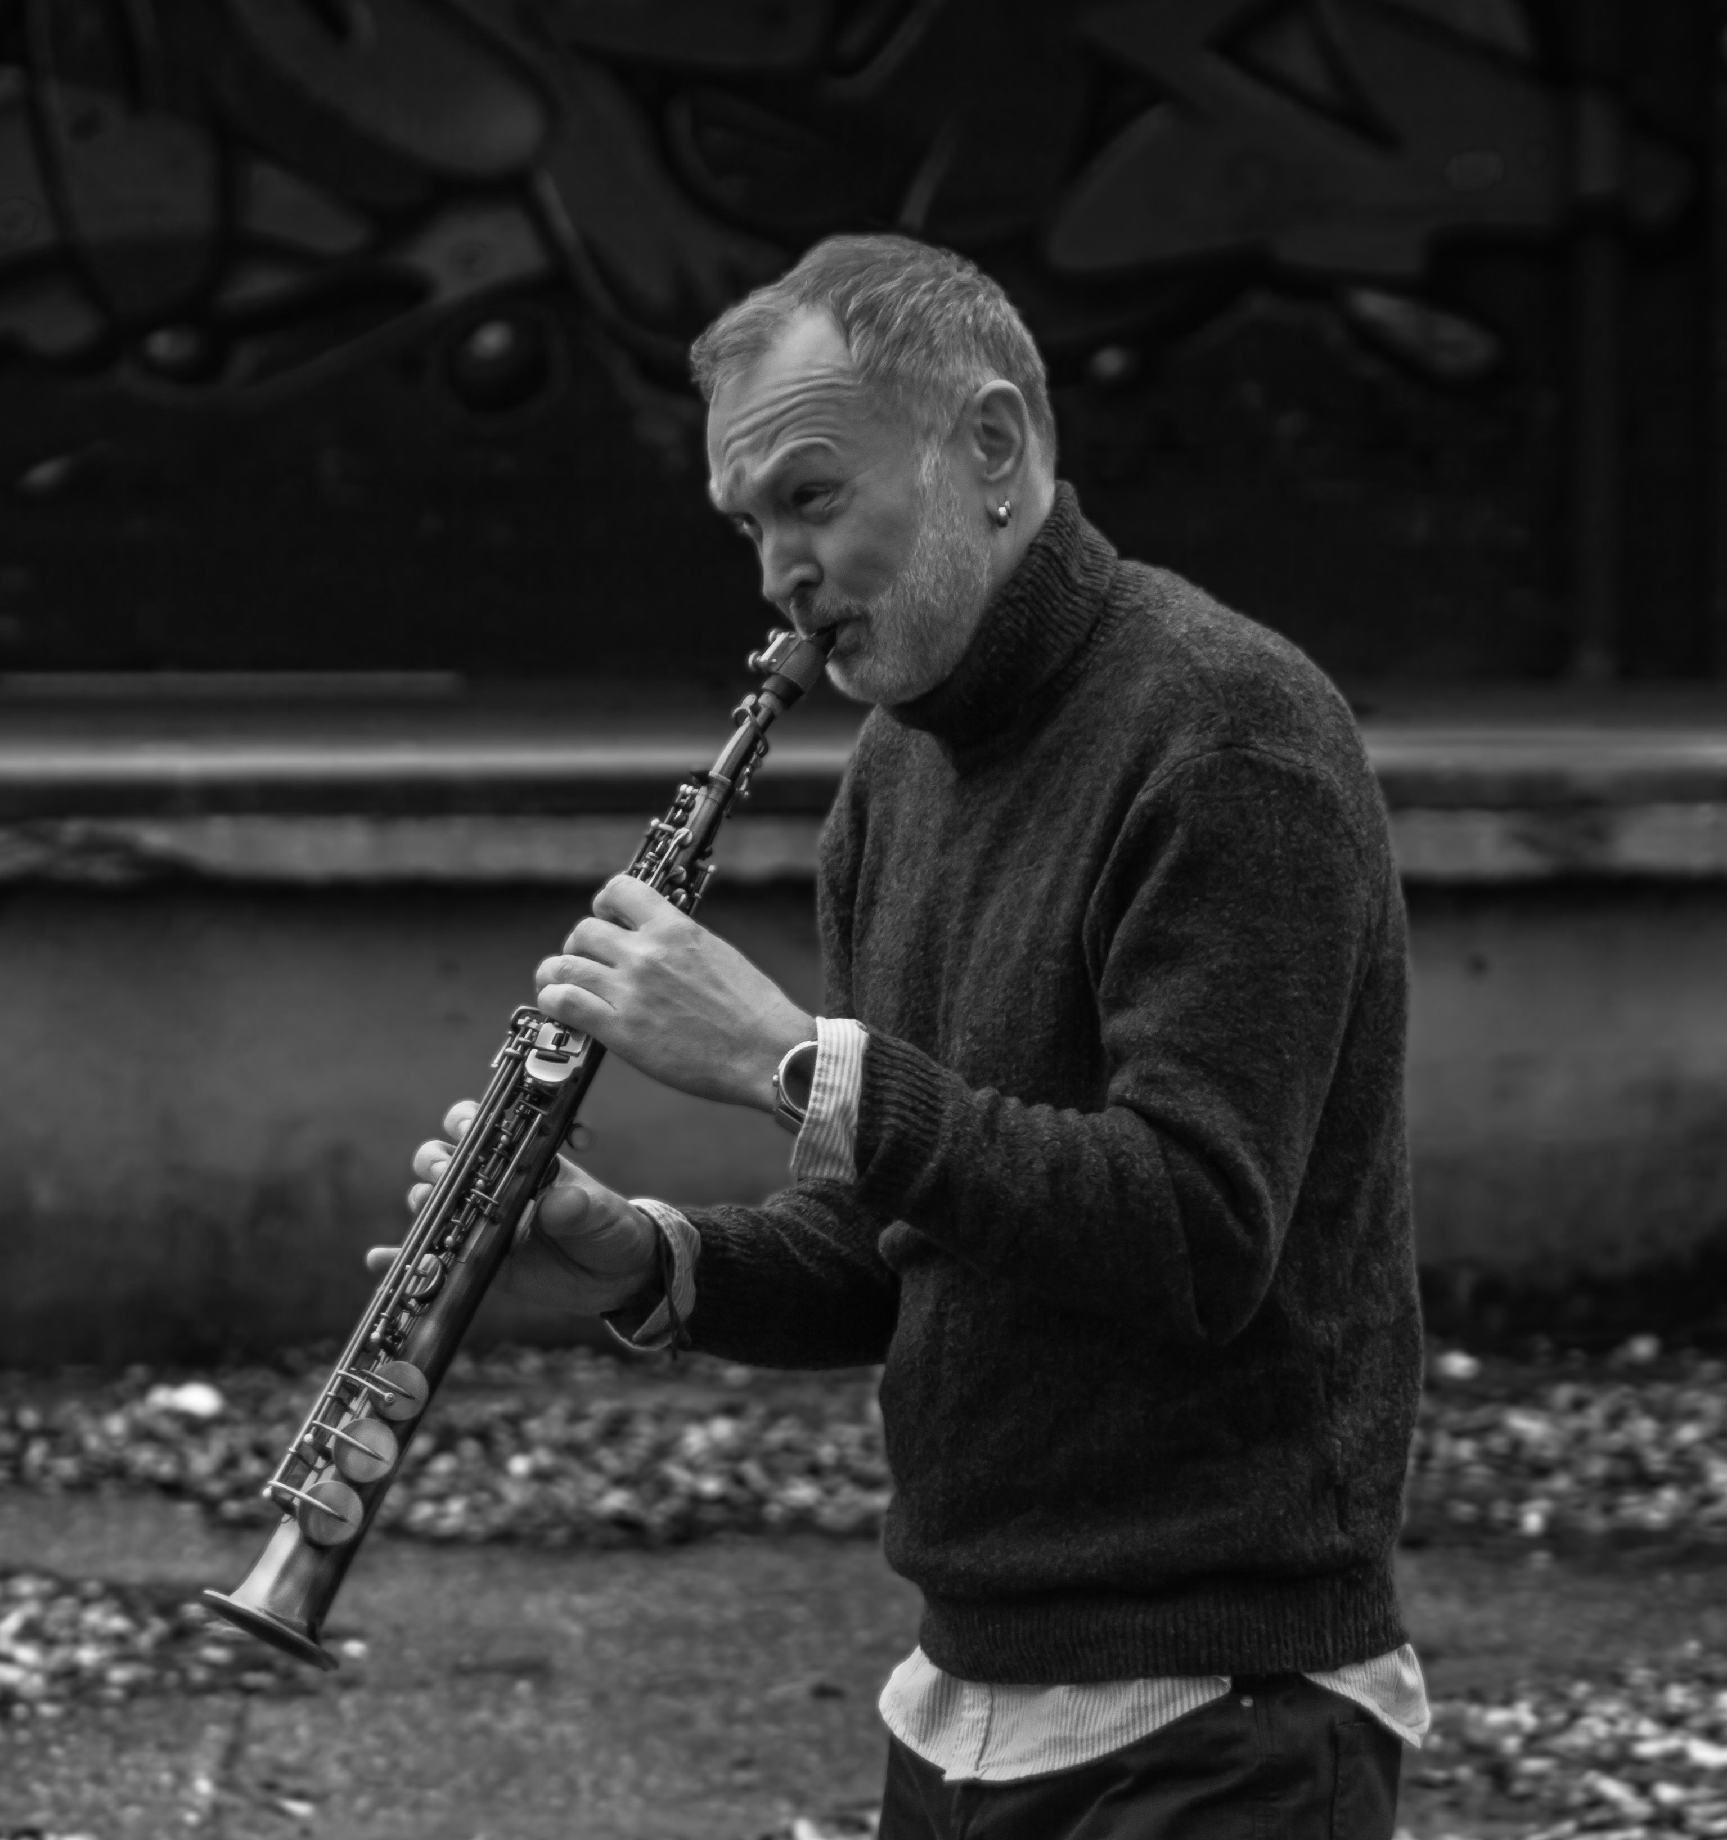

Max Kochetov (saxophonist, composer and arranger) was born in Kiev (Ukraine) on January 9th, 1979. His first music experience was at the age of six, when he started to learn accordion and clarinet in music school. At the age of nine he started to learn and play saxophone in children brass and jazz orchestras.

From 1992 to 1997 he was a student of saxophone in Kiev State Music College “R.M.Gliera”.

Since 1995 he was a member of the Evgeniy Dergunov quintet and had won awards on many jazz festivals.

In 1997 he went to Erfurt (Germany), where he’s taking lessons in jazz summer school from one of the most recognized European saxophone players Zbigniew Namyslowski (Poland). He attended ensemble lessons in the class of John Taylor (Great Britain). Parallel, he was playing jazz in many clubs in Germany and France.

Since 2006 he lives and works in Belgrade (Serbia).

In 2010, he became lead alto saxophonist in Big Band of Radio Television of Serbia (RTS).
At the same time he forms the “Max Kochetov Quartet” and performs on many jazz festivals around Serbia and Europe.

Max Kochetov has presented in his work four of his quartet albums so far in collaboration with eminent musicians.

The music is characterized by ingrained elements of traditional sound with a touch of modern expression in exciting and unpredictable flow.

He collaborated with many musicians like:
Dusko Gojkovic, Jon Faddis, Dave Weckl, Brad Leali, Seamus Blake, Fabrizio Bosso, Alex Sipiagin, Samuel Blaser, Clause Raible, Chuck Findley, John Fedchock, Gregory Hutchinson, Heinz von Hermann, Bert Joris, Jure Pukl, Vladimir Molotkov, Igor Zakus, Marko Churnchetz, Dusan Novakov, Vladimir Kostadinović, Steve Fishwick, Martin Gjakonovski, and others.
Albums:
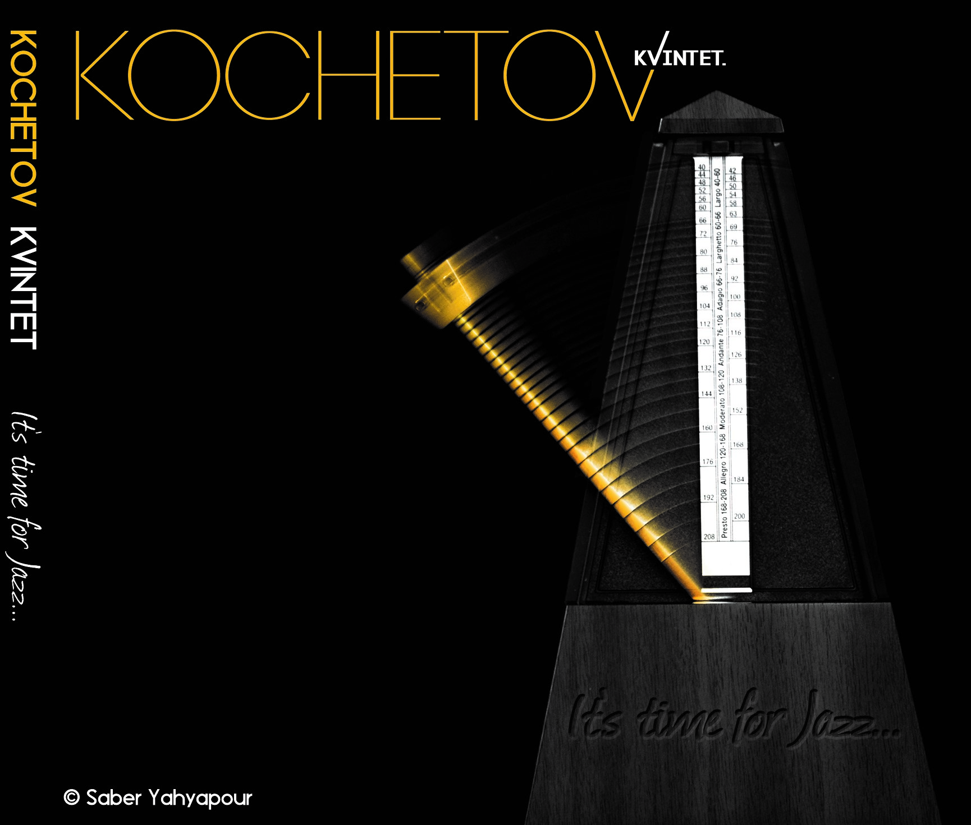 “It’s Time For Jazz”
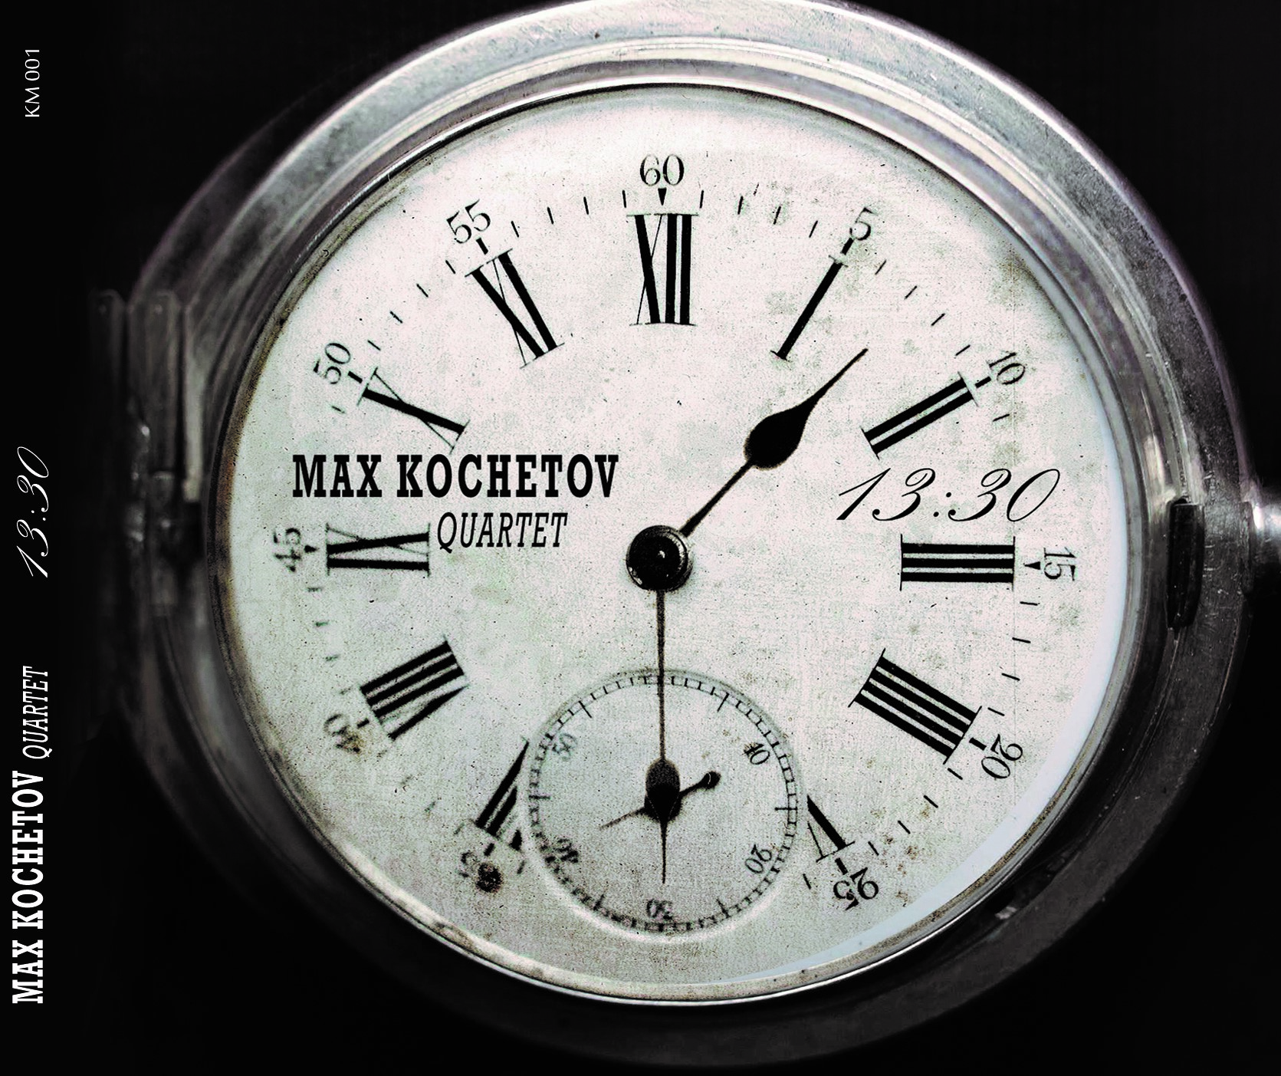 “13:30”
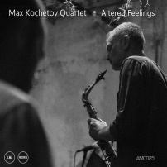 “Altered Feelings”
Links:
https://open.spotify.com/album/5YaNJvLHgAr08u9LSV4F3o
https://www.deezer.com/sr/album/395421957
https://amarecordsamaedizioni.bandcamp.com/album/altered-feelings

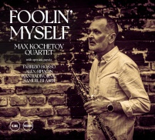 “Foolin’ Myself”
Links:
https://open.spotify.com/artist/02fCFithwTwZ9QzHjzm55i
https://www.deezer.com/sr/album/895647412
https://amarecordsamaedizioni.bandcamp.com/album/foolin-myself

Label:
http://www.amaedizioni.it/artist?id=33&lang=en

Reviews:
https://ukvibe.org/album_reviews/max-kochetov-quartet/
https://www.paris-move.com/reviews/max-kochetov-quartet-foolin-myself/
https://offtopicmagazine.net/2022/02/18/max-kochetov-quartet-altered-feelings/
https://www.paris-move.com/reviews/max-kochetov-quartet-altered-feelings/

Links:
https://www.youtube.com/watch?v=gdM-kmqA5RY&list=OLAK5uy_mQZOJ9bmPPYoFD1pis9nit9-xHKpflS48&index=2
https://www.youtube.com/watch?v=-zo-jF7SOac
https://www.youtube.com/watch?v=-AhAH5_k1rE
https://www.youtube.com/watch?v=Tc6H2GuC2uE&t=2832s
https://www.youtube.com/watch?v=1OWjDRZovWA
https://youtu.be/-XO44ZbKQOE
https://www.youtube.com/watch?v=RhVdfsbTTts&list=PLjL0EbX4fRpGTYRqKW-exW2xZWoXZ9Ruk&index=2
https://www.youtube.com/watch?v=KGD_n3C7fvw&list=PLjL0EbX4fRpGTYRqKW-exW2xZWoXZ9Ruk&index=3
https://www.youtube.com/watch?v=atGhFmNMKqw&list=PLjL0EbX4fRpGTYRqKW-exW2xZWoXZ9Ruk&index=4
https://www.youtube.com/watch?v=1UBcx-wmz4k&list=PLjL0EbX4fRpGTYRqKW-exW2xZWoXZ9Ruk&index=5
https://www.youtube.com/watch?v=Su20uWpa4ck&list=PLjL0EbX4fRpGTYRqKW-exW2xZWoXZ9Ruk&index=6

Contact:
maxkochetov.quartet@gmail.com
+381611742519

